WebSphere Deployment

Table of Contents

**Template Generation** 2

1. Create Component 3

2. Set Properties 4

3. Create Process for Component 5

**Resource Creation** 7

1. Create Resource 7

2. Map agent to resource 8

3. Configure WebSphere Cell 8

**Application Creation (Template Generation)** 9

1. Creating application 9

2. Mapping Component to application. 10

3. Creating an Envionment 10

4. Adding Resource to your environment 11

5. Creating Process 12

6. Run your Environment 13

**Component Creation(Deployment)** 14

1. Create Component 14

2. Create Process for component 16

**Create Application(Deployment)** 22

1. Create Application 22

2. Map Components 22

3. Creating Environment 23

4. Create Process for Application 24

**Run the environment** 26

# **Template Generation**

## Create Component

In UrbanCode Deploy, to create the new component, Click on **Component** 🡺 **Create** **Component.**

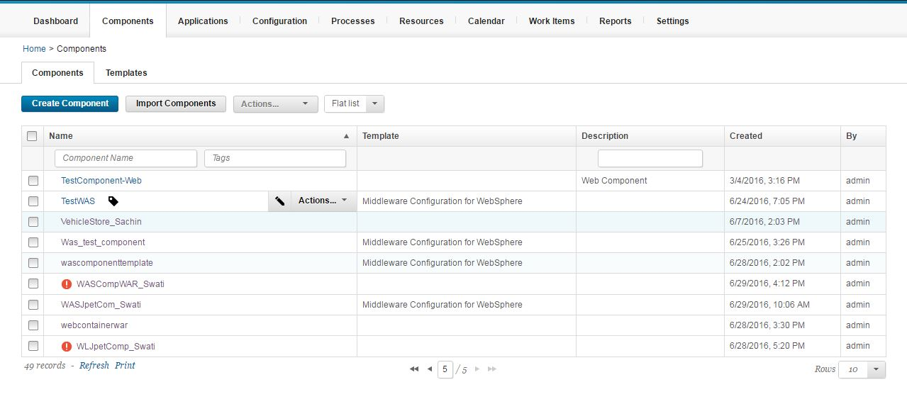

1. In the **Name** field, type (component_name), WasJpetComp_Swati.
2. Select **Template** as Middleware Configuration for WebSphere.
3. Accept the default values for the other fields on the page.

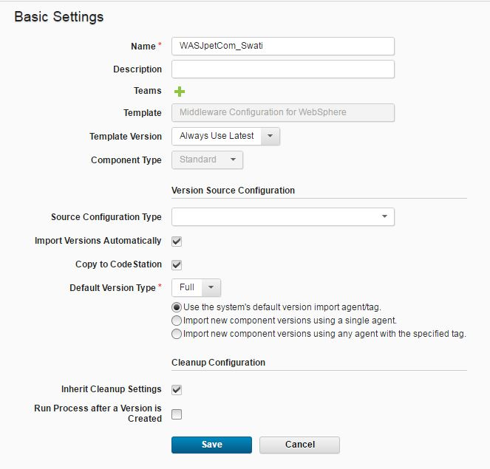

Component WasJpetComp_Swati is created.

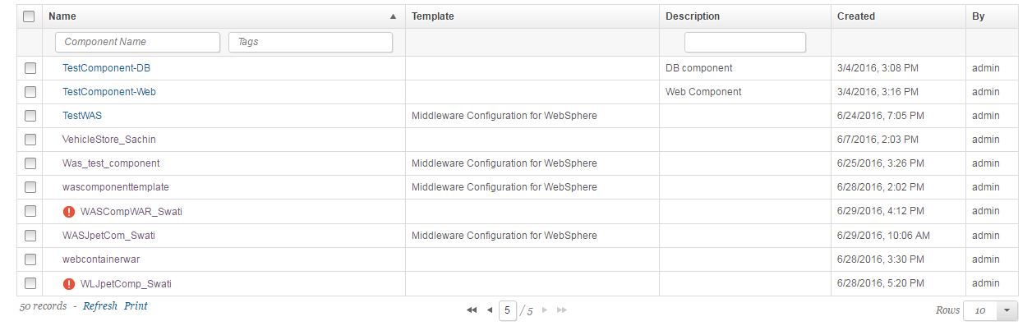

## Set Properties

Click on your component(WasJpetComp_Swati) 🡺 Configuration 🡺 Environment Property Definitions.

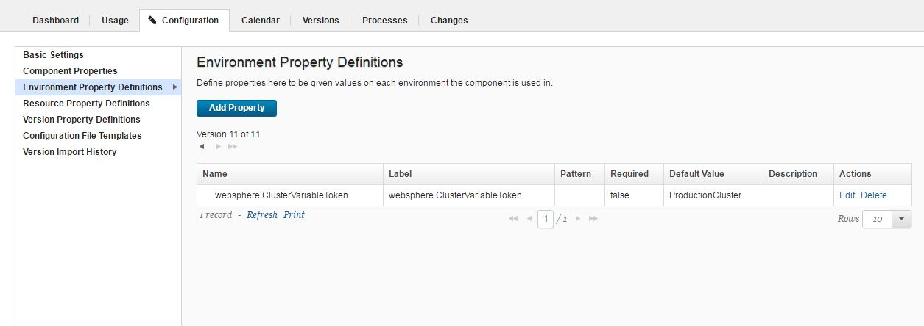

Set the following properties-:

Label-:websphere.ClusterVariableToken

Default Value-:ProductionCluster

Click Save.

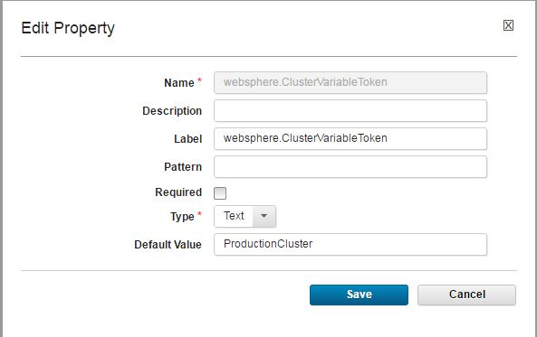

## Create Process for Component

Process 🡺 Create Process

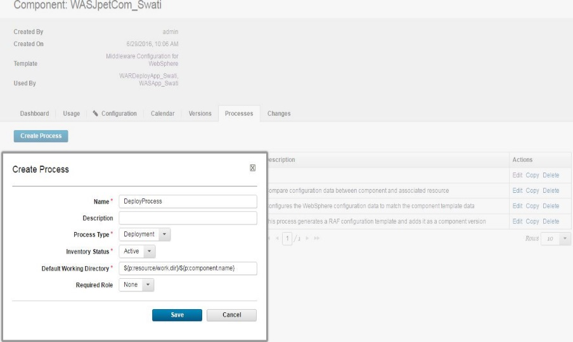

Click **Edit**

You add steps to the process and link them between the **Start** and **Finish** steps to show the order of the steps.

Add **Install Application, and give**

1. Context Root
2. Application Name
3. Application Source

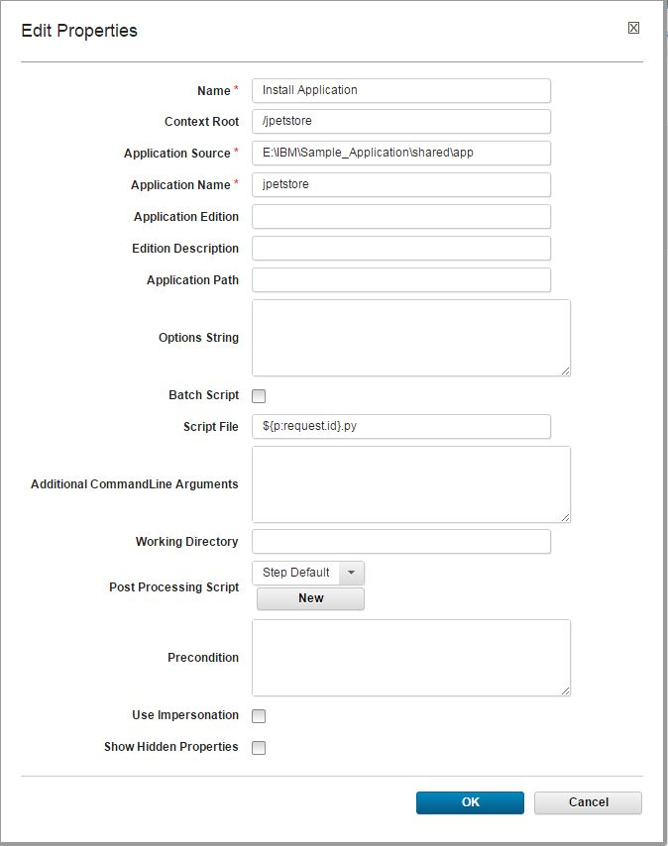

Now the process has the following figure:

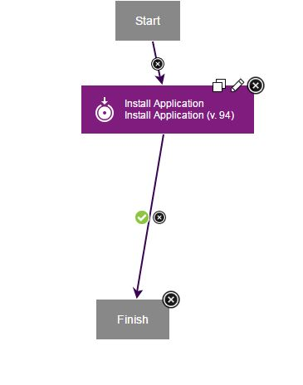

# **Resource Creation**

## Create Resource

Click **Resoures** 🡺**Create Top-Level Goup**

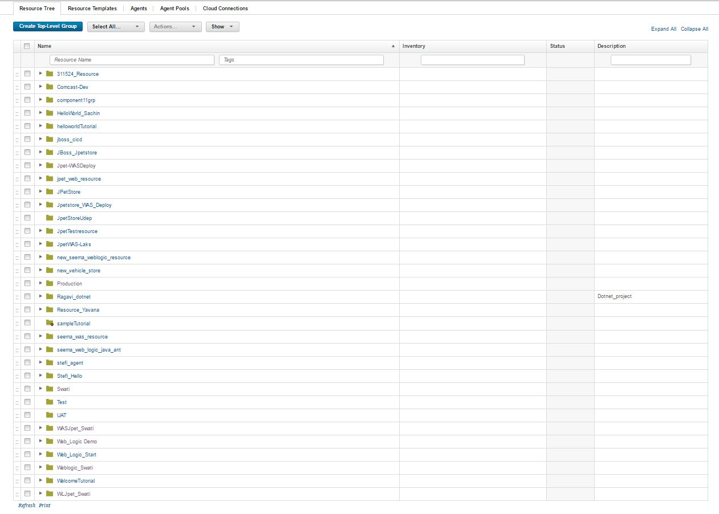

## Map agent to resource

**Add Agent** as shown-:

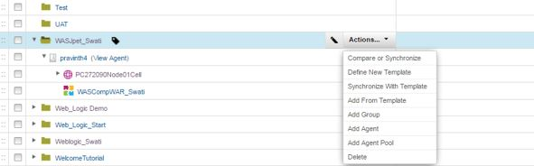

## Configure WebSphere Cell

Then click **Refresh**. A twisty is now next to the agent. When you expand it, there is a sub-resource cell, **WebSphereCell**. Click **Edit**.

Enter values for the following properties.

* WebSphere Profile Path
* WebSphere User
* WebSphere Password

Click Save.

Expand **WebSphereCell (**PC272090Node01Cell**), Server Cluster 🡺 Add Component**

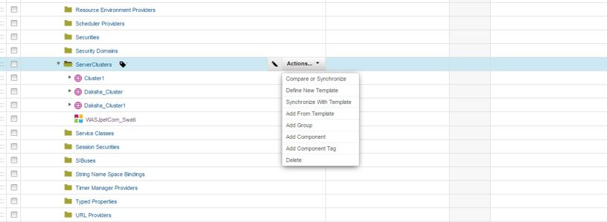

Click on **Component(**WasJpetComp_Swati**) 🡺 Configuration 🡺 Resource Properties**

Set the following property-:

websphere.profilePath-: E:\IBM\WebSphere2\AppServer\profiles\AppSrv01

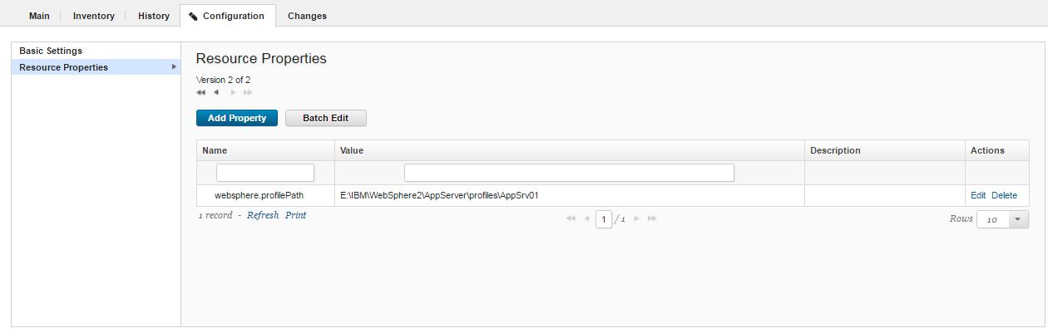

# **Application Creation (Template Generation)**

## Creating application

Click **Application** 🡺 **Create New Application**

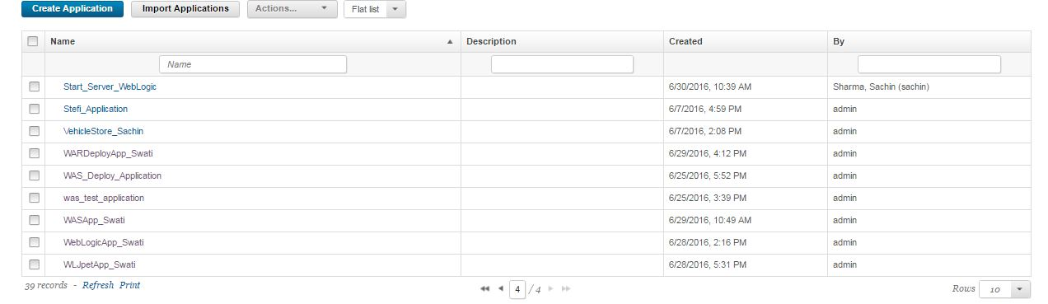

## Mapping Component to application.

Click **Component** 🡺 **Add Component**

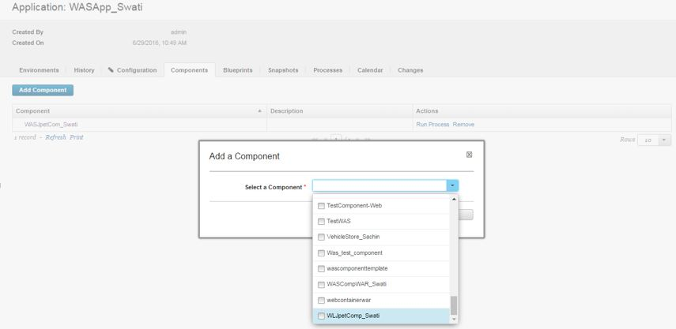

## Creating an Envionment

Click Environment 🡺 Create New environment

Give Name-: Dev 🡺**Save**

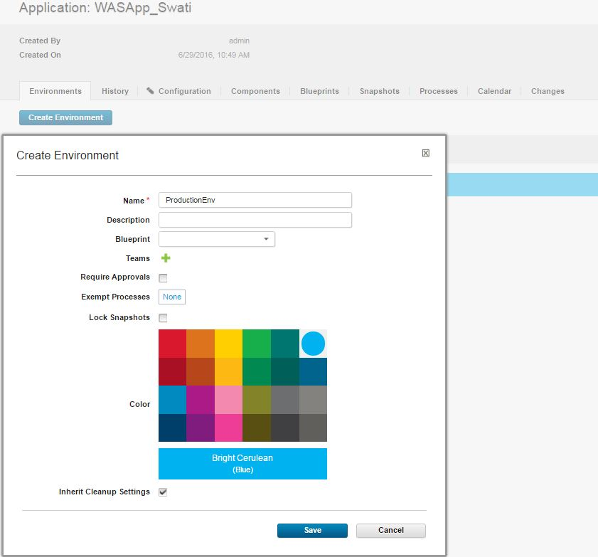

## Adding Resource to your environment

Click your Environment(ProductionEnv) 🡺 **Add Base Resources 🡺** select your agent

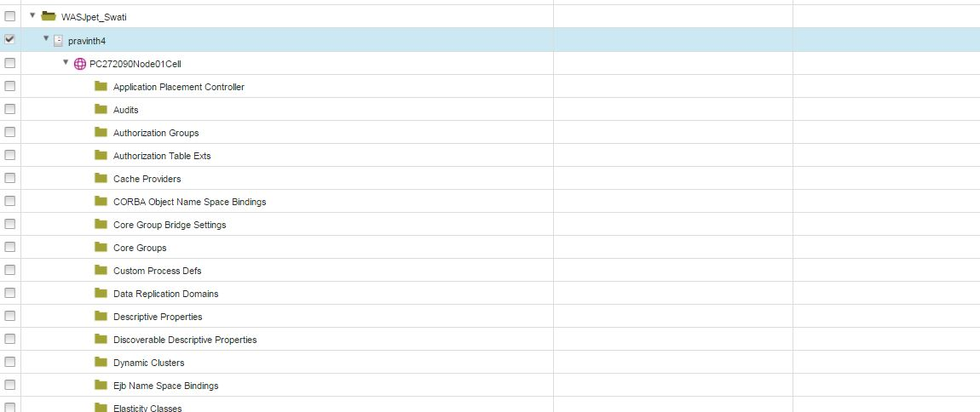

## Creating Process

Click **Process** 🡺 **Create Process**

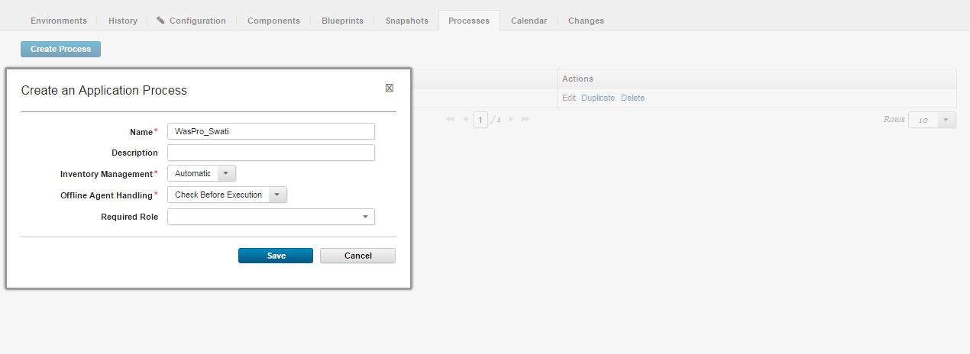

On your created Process(WasPro_Swati) 🡺 **Edit**

Select **Generate Template.**

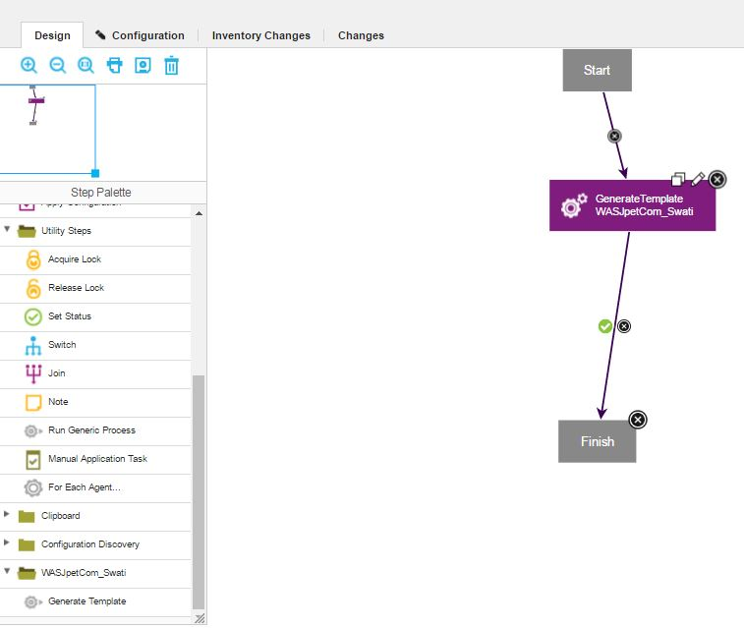

Give **Name** and Click **Save**.

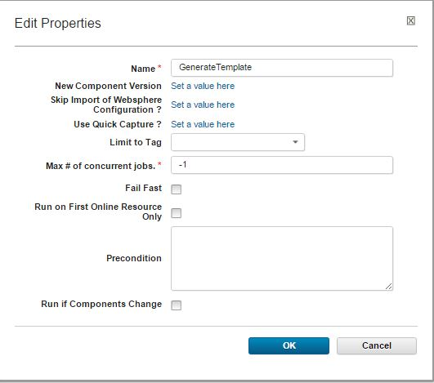

## Run your Environment

You will find your Environment running successfully.

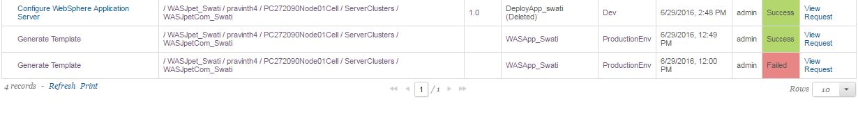

# **Component Creation(Deployment)**

## Create Component

Click **Component** 🡺 Create **Component**

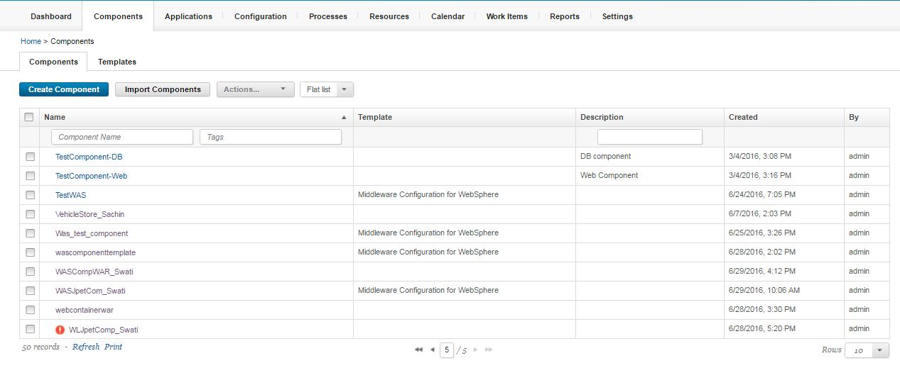

Set the following field,

1. In the **Name** field, type (component_name),WASCompWAR_Swati.
2. In the **Source Configuration Type** list, select **File System**.
3. In the **Base Path** field, specify the location of the app folder on the server, such as D:\Swati Jenkins\workspace\samplemaven.
4. Under **Default Version Type**, click **Import new component versions using a single agent** and then select your agent in the **Agent for Version Imports** list
5. Accept the default values for the other fields on the page.

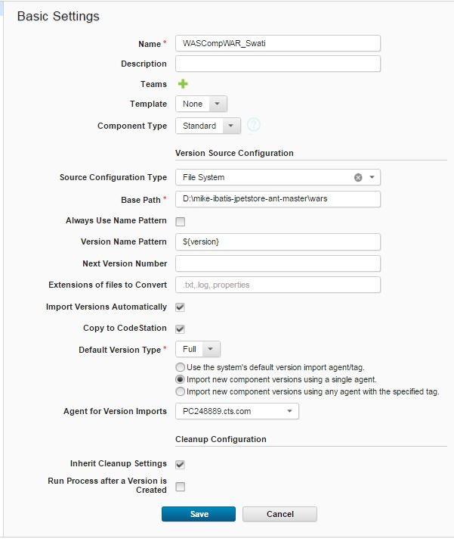

Component WASCompWAR_Swati is created.



## Create Process for component

Click on **Component** 🡺 **Process** 🡺 **Create Process**

Give **Name** ofProcess **🡺 Save**

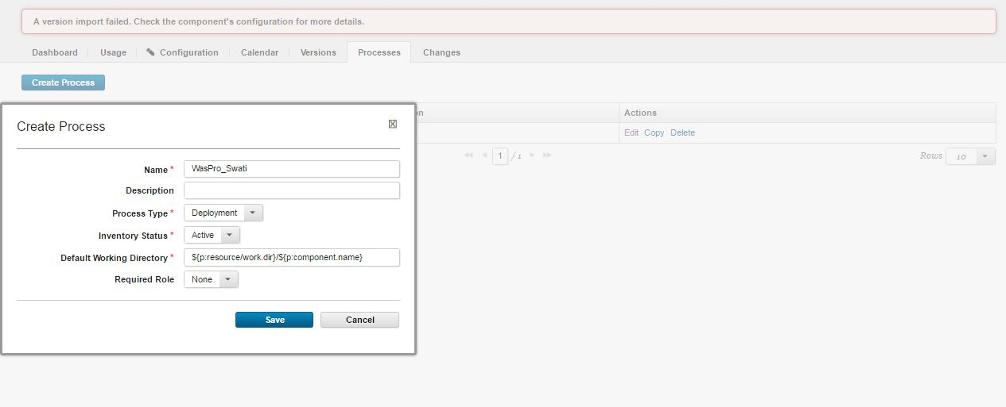

The **Start** and **Finish** boxes represent the beginning and the end of the process. From here, you add steps to the process and link them between the **Start** and **Finish** steps to show the order of the steps.

First add the step **Create Cluster,**

1. In Custer Name field give of cluster(Clustre_01)
2. Click on Show Hidden Properties, and add the following

* Command Path
* User Name
* Password
* Host
* Port

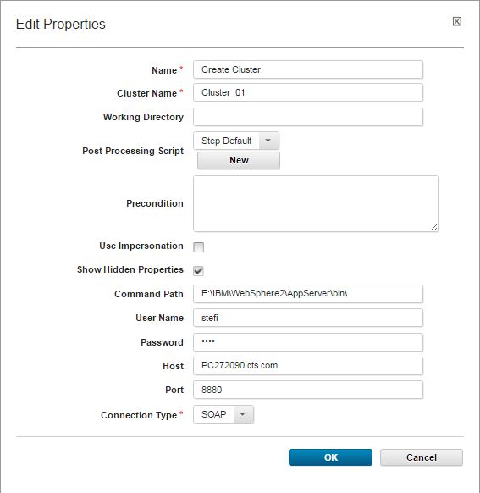

Second add **Wait for server or cluster**

1. Give Timeout(seconds), Interval(seconds)
2. In show hidden fields, give the following value

* Command Path
* User Name
* Password
* Host
* Port

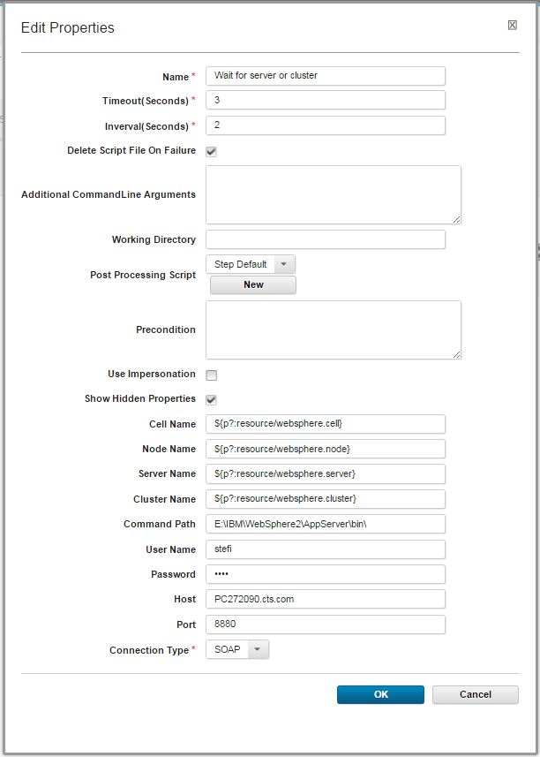

Third add **Download Artifacts**, take all the default value in it as shown.

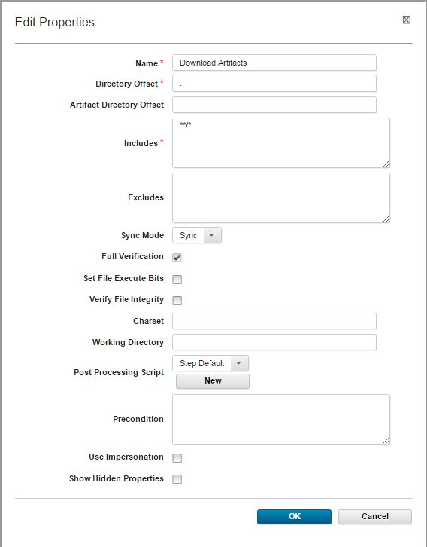

Last step add **Install and Update Application**, set he following fields,

1. Set Application Source
2. Set Application Name
3. Check Show Hiden Fields,set the following fields

* Command Path
* User Name
* Password
* Host
* Port



Now the process has four steps, as in the following figure:

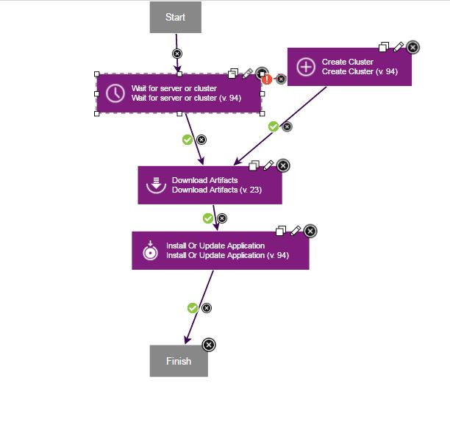

# **Create Application(Deployment)**

## Create Application

Click Application 🡺 Create Application

Give Name of application, application is created (WARDeployApp_Swati).

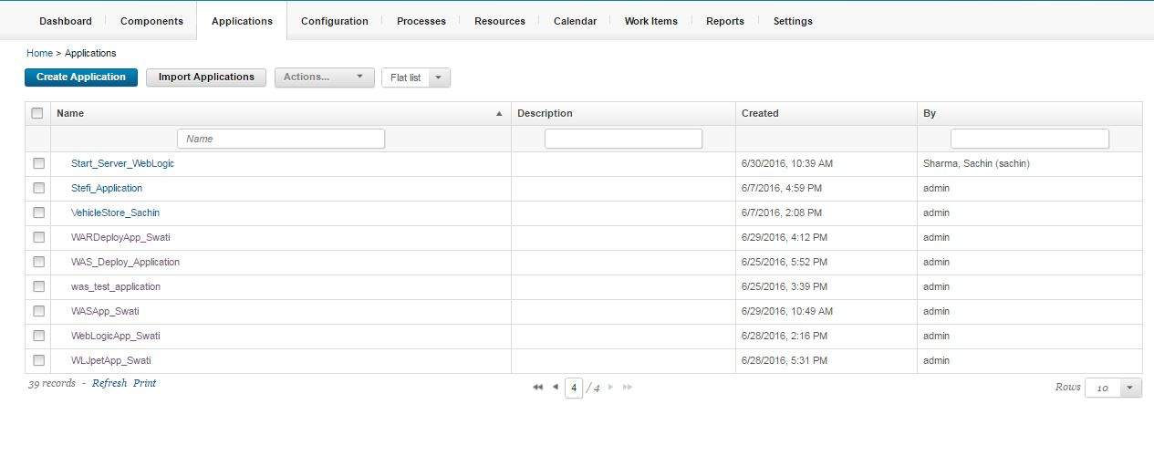

## Map Components

Click **Components** 🡺 **Add Components**

Add the first component you created and then add second component you created as shown.

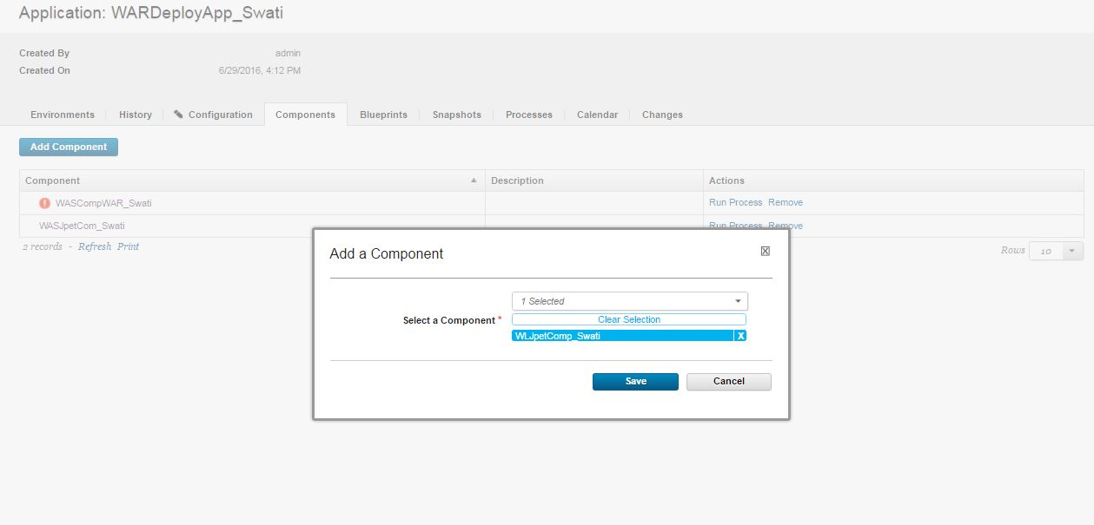

Both components are mapped with application.

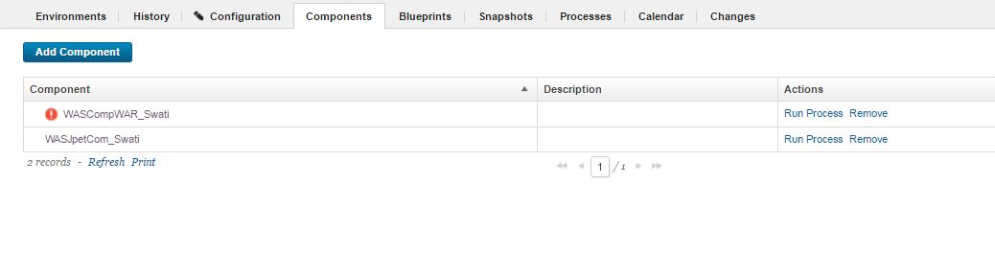

## Creating Environment

Click **Environment** 🡺 **Create Environment 🡺 Name-: Dev**

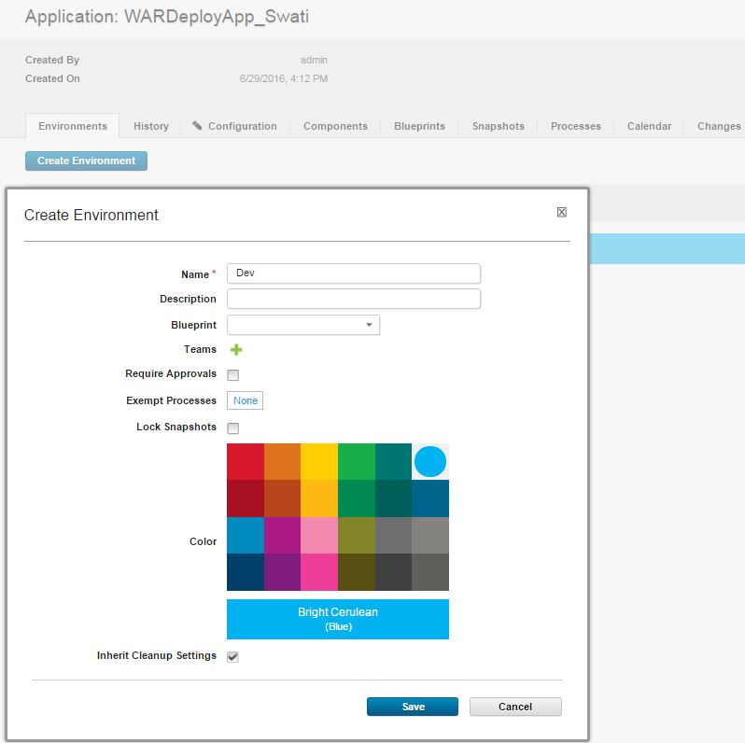

## Create Process for Application

Select your **Application 🡺 Process 🡺 Create Process**

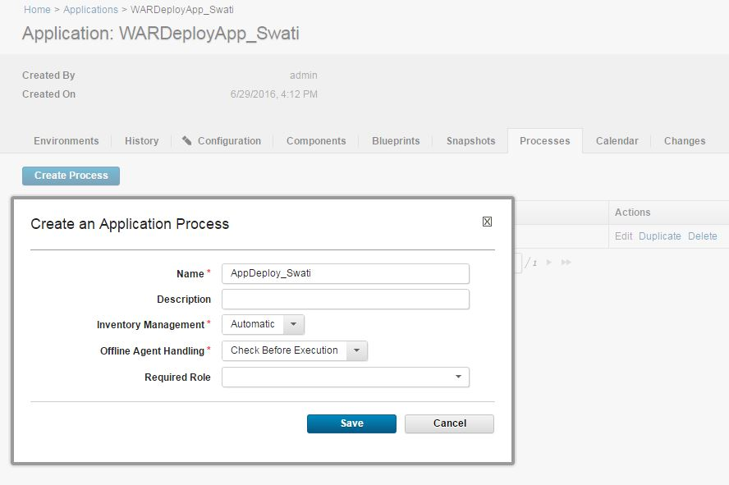

Click **Edit,** you add steps to the process and link them between the **Start** and **Finish** steps to show the order of the steps.

First add **Install Component**, set the **Component Process** as **Configure Websphere Application Server(Template)** and select the **Component** you created first(WASJpetCom_Swati).

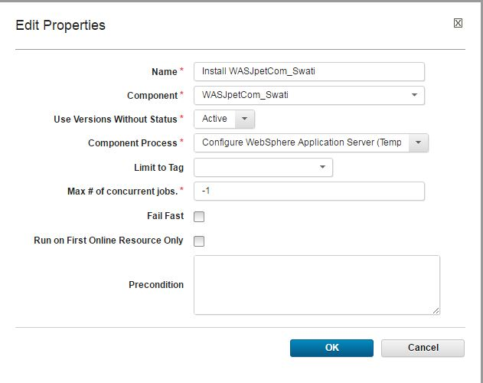

Second again add **Install Component**, select the **Component** you created for Deployment(WASCompWAR_Swati) because this deployes the war file.

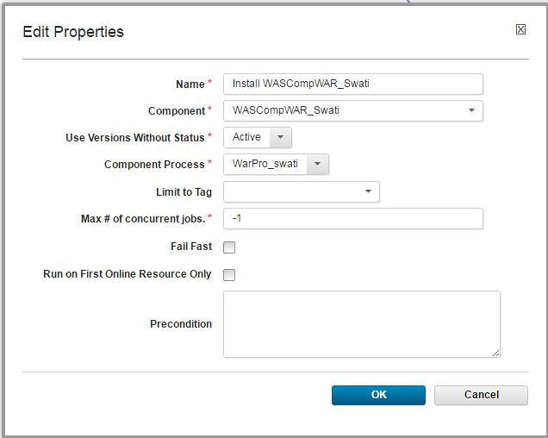

Now the process has two steps, as in the following figure-:

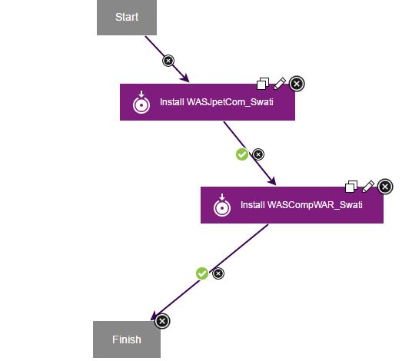

# **Run the environment**

